Experiment 8
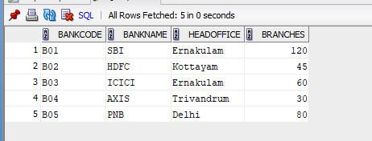

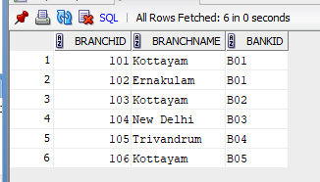
1. create view BANK_HEAD_OFFICE_2 as select * from BANK_2 where HEADOFFICE = 'Ernakulam';
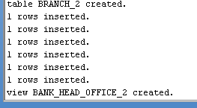
SELECT * FROM BANK_HEAD_OFFICE_2;
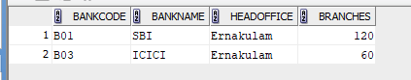
2. create view BANK_BRANCH_2 as select distinct B.* from BANK_2 B join BRANCH_2 BR on B.BANKCODE = BR.BANKID where BR.BRANCHNAME = 'Kottayam';
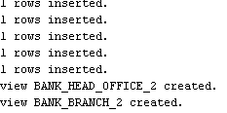
SELECT * FROM BANK_BRANCH_2;
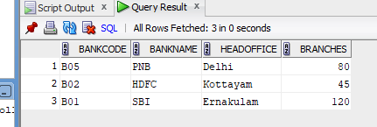
3. CREATE VIEW bank_more_than_50_2 AS SELECT * from BANK_2 WHERE BRANCHES > 50;
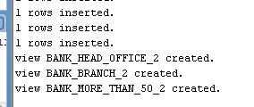
SELECT * FROM BANK_MORE_THAN_50_2;
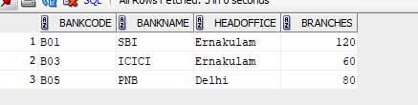
4. CREATE VIEW bank_branch_details_2 AS SELECT b.BANKNAME, br.BRANCHNAME FROM BANK_2 b JOIN BRANCH_2 br ON b.BANKCODE = br.BANKID;
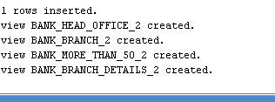
SELECT * FROM BANK_BRANCH_DETAILS_2;
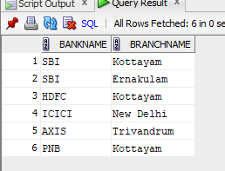
5. CREATE VIEW bank_outside_ernakulam_2 AS SELECT *from BANK_2 WHERE HEADOFFICE <> 'Ernakulam';
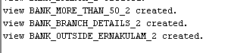
SELECT * FROM BANK_OUTSIDE_ERNAKULAM_2;
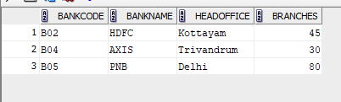
select * from BRANCH_2;

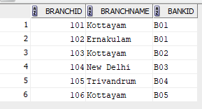
select * from BANK_BRANCH_2;
